*Ruben Espana*

*Javier Macossay-Hernández*

**EE 202 Final Project**

*Amplifier*

The 741 op-amp was used in the configuration of an inverting amplifier to increase the volume of the electrical signal from the guitar. To adequately hear the signal through the speakers we wanted a gain of 100. To get the gain that we wanted we used Rin = 1kΩ and Rf = 100kΩ. We connected the signal of the guitar to pin 2 whichlso has Rin while the output leaves from pin 6 into the bandpass filter. We connected +12/-12 V to pins 7 & 4 respectively.

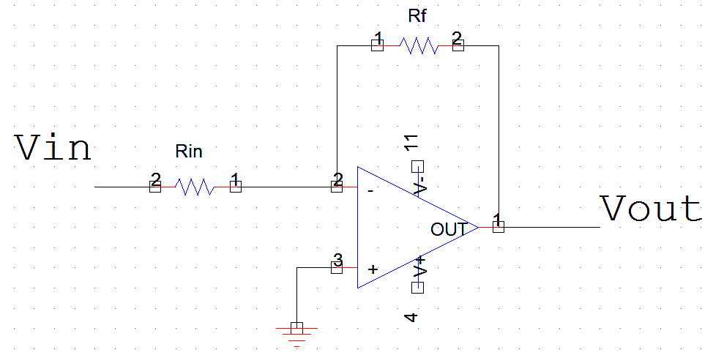

*Bandpass Filter*

In the second section, we used a LM741 to build the bandpass filter. We used a quality factor Q of 9.8, frequency input is 196 (that is the frequency for the G string), a bandwidth of 20. We used three parallel 3.3 MΩ and five 100 kΩ in series for R3 (1600 kΩ), one 80 kΩ resistor for R1, four series 1 kΩ and four series 100 Ω for R2, and two 10 nF for C1 and C2. Pin 7 and pin 4 were connected to $± 15 V$ the power supply.

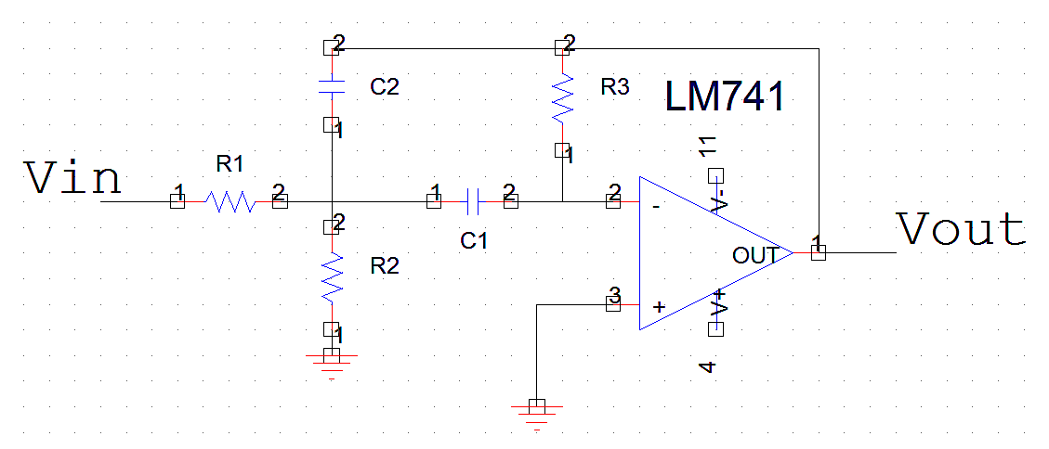

*Frequency to Voltage Converter*

For the frequency to voltage converter we used the LM2917N chip which contained 14 pins. However, in order to use this chip we had to convert the 8pin schematic shown below so that it would correspond accordingly to the 14 pin schematic shown. We did this by jumping pin 3 to pin 4 and pin 5 to pin 9.

The resistors and capacitors we used are shown in the 3rd schematic they are as follows:

C1 = 1 microF, C2= 0.02 microF

R1= 470 ohms, R2 = 100k ohms, R3 = 10k ohms

Once we connected this to the voltmeter the output voltage we obtained was 2.85 Volts.

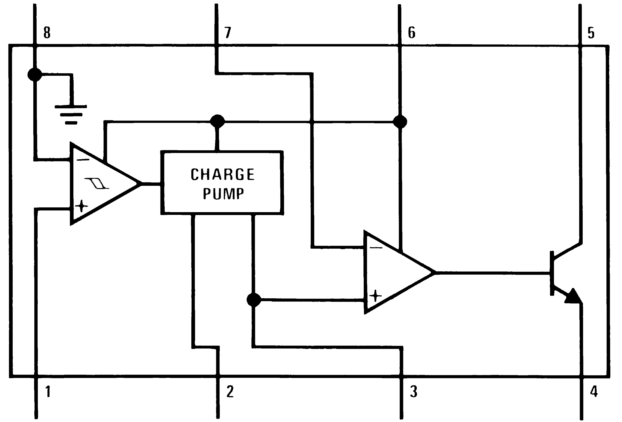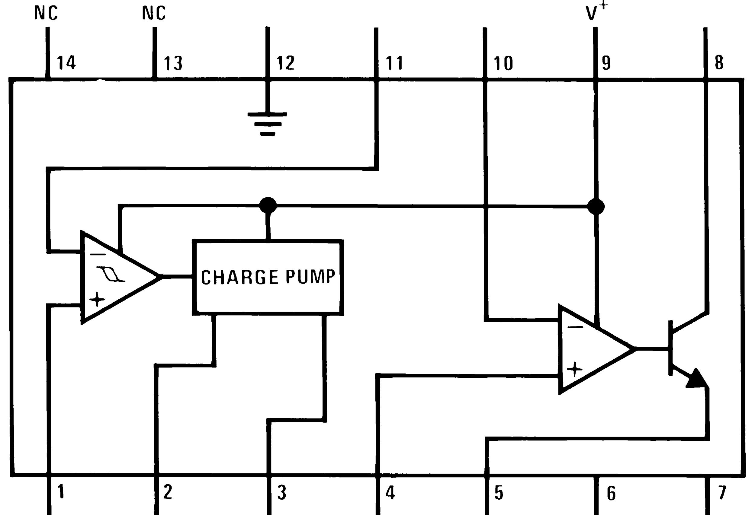

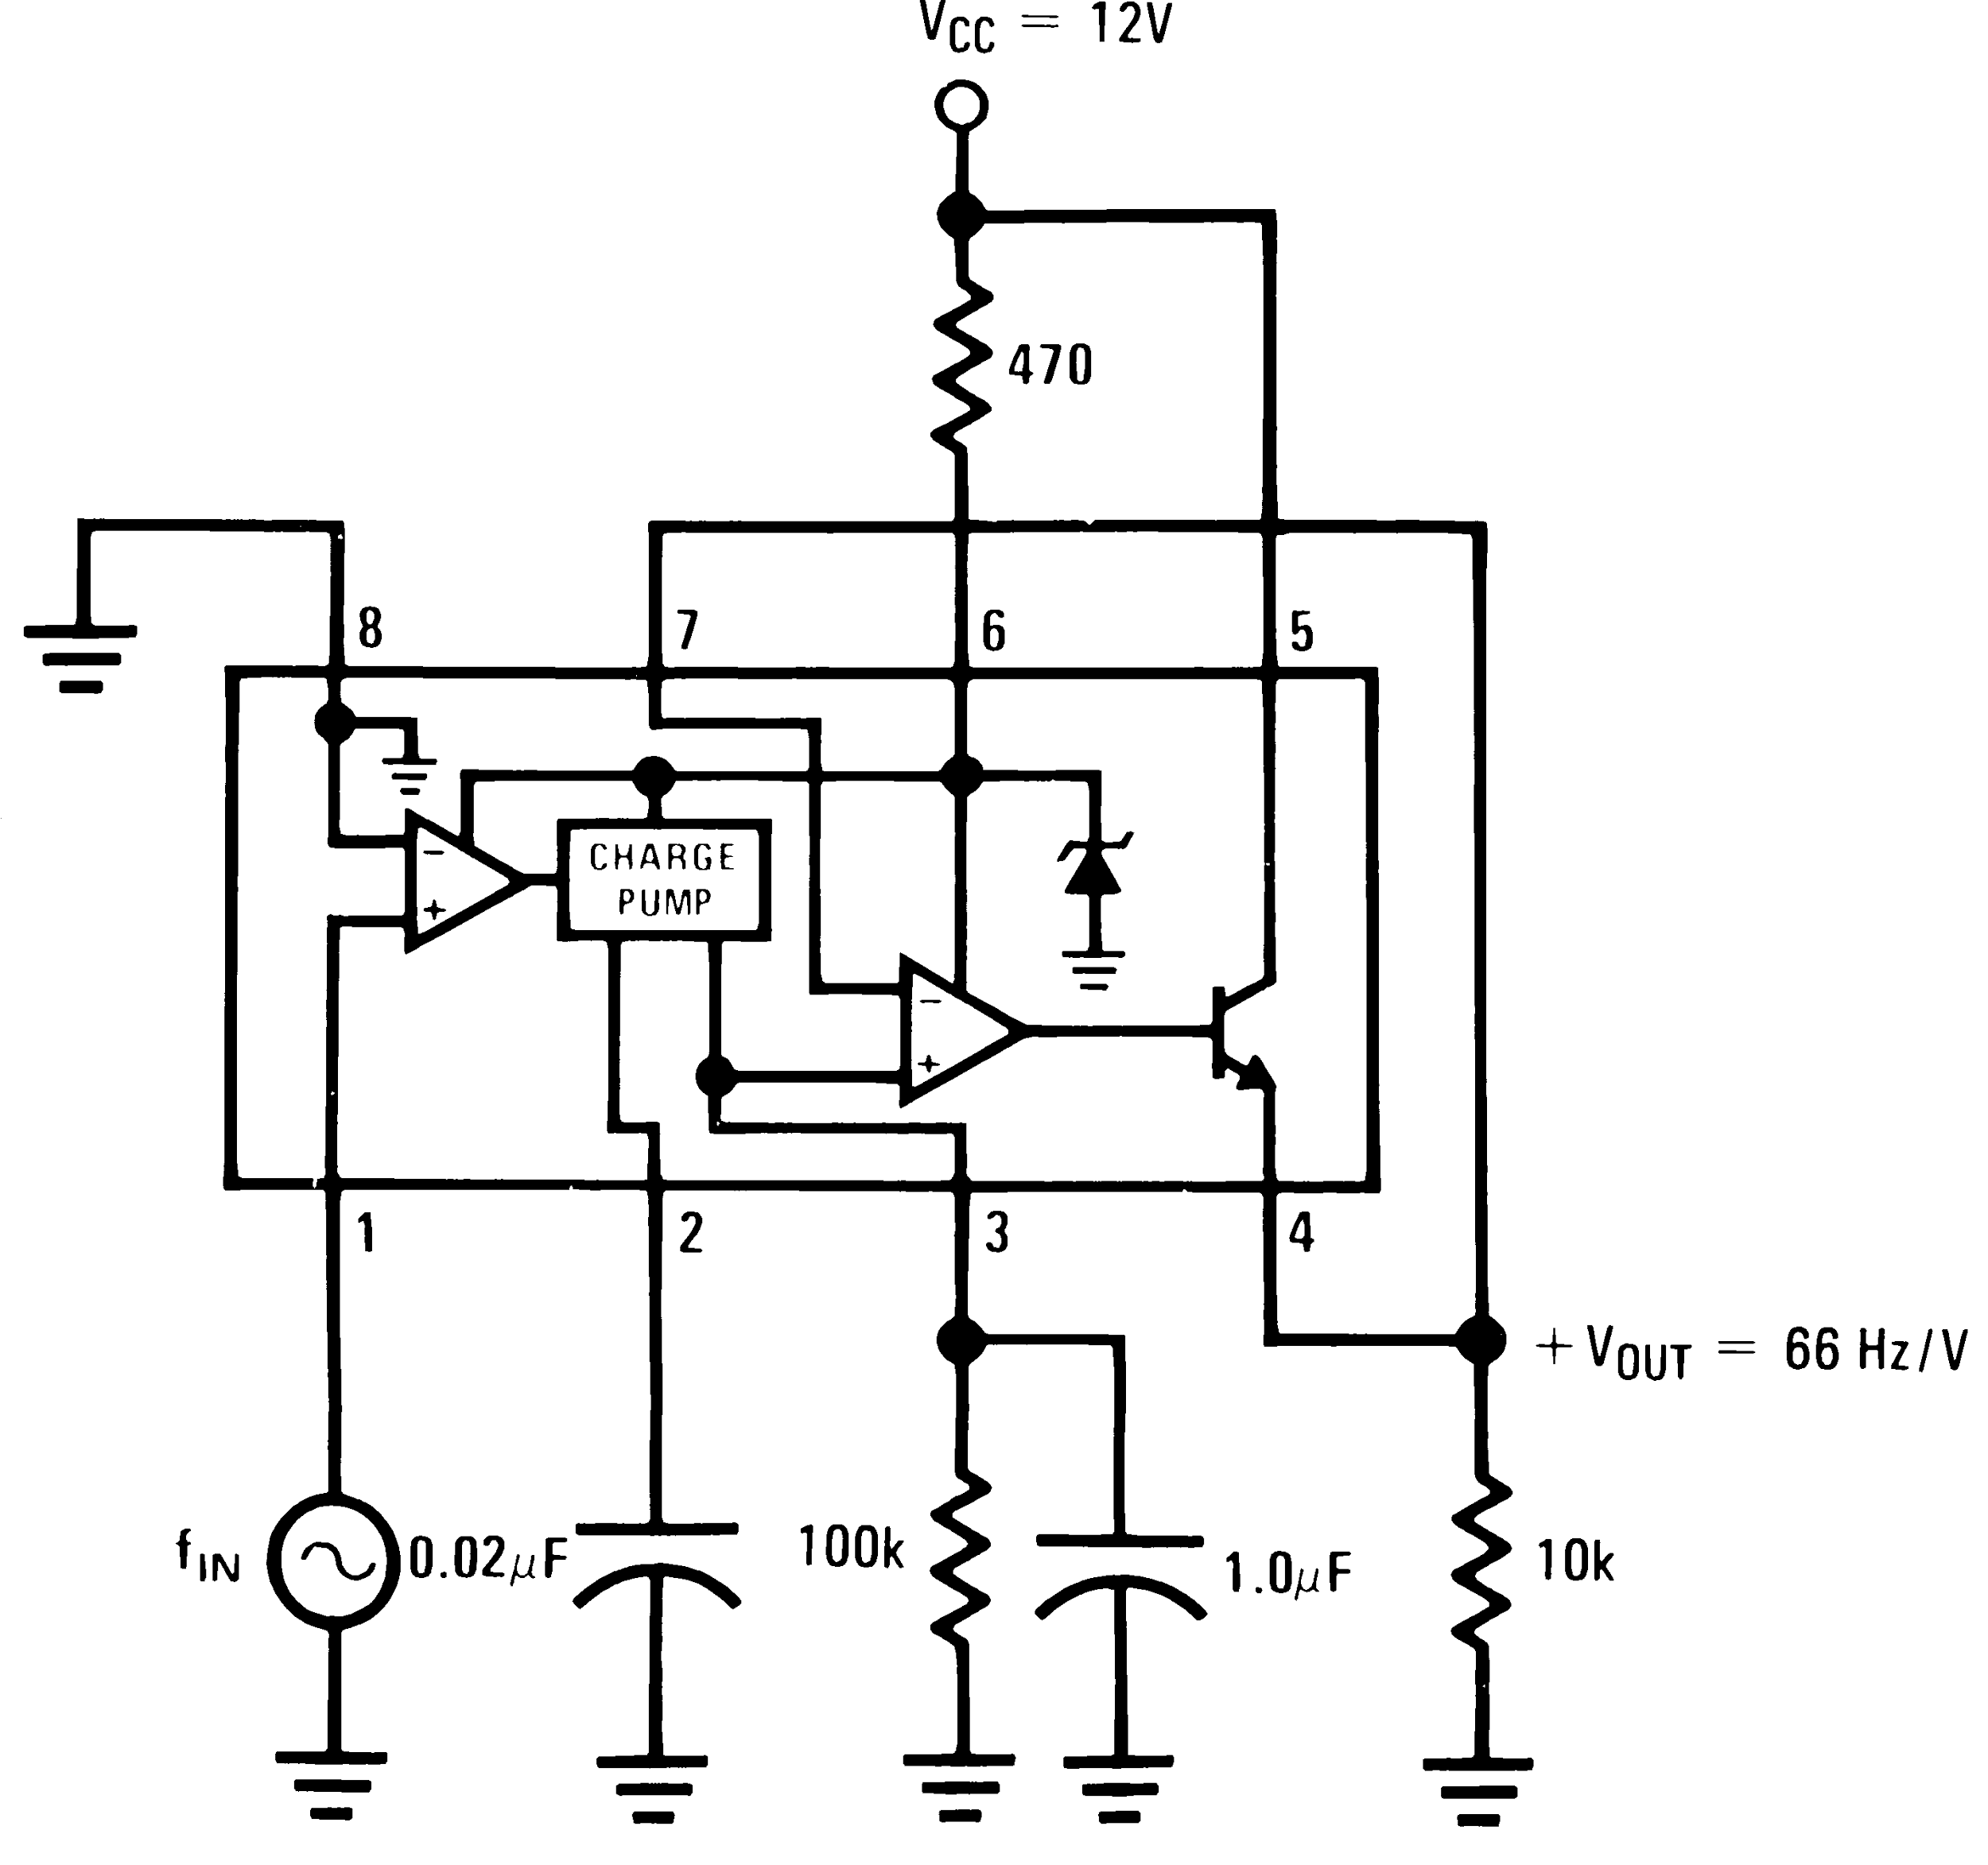

*Comparator and LED*

In order to obtain the upper and lower bound voltages we added and subtracted approximately 10 Hz from our central frequency. The values we obtained for +10 Hz gave a voltage of 2.98V and the -10 Hz gave a voltage of 2.71 Volts. Thus the upper bound is 2.98V and the lower bound is 2.71V. In order to obtain these voltages, we built a voltage divider that included the op amp LN393. The resistances we used for the upper bound voltages were R1 = 100k and R2 = 33.63k. For the lower bound voltage we used R3 = 100k and R4 = 29.45k. We also used 3.3M ohm resistors (R5 and R6) for the LED lights.

The central frequency we obtained is 196 Hz. When the frequencies are between 206 Hz and 186Hz both of our LED lights light up which means that the string is in tune. However, when the frequency of the string is below 186 Hz only the red light lights up and when the frequency is above 206 Hz only the green light lights up.

